Nama : Rendy Irawan

NIM : 19020034

Kelas : Semester 6 Shift

Ket : Tugas screenshot Composer dan CodeIgniter 4

Composer

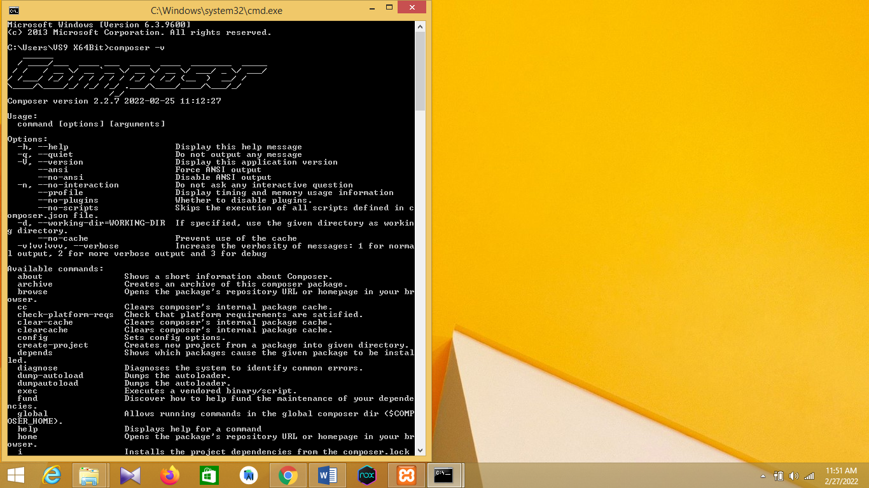

CodeIgniter 4

